**Compiler Course Work Part II Report**

Task II-1 :

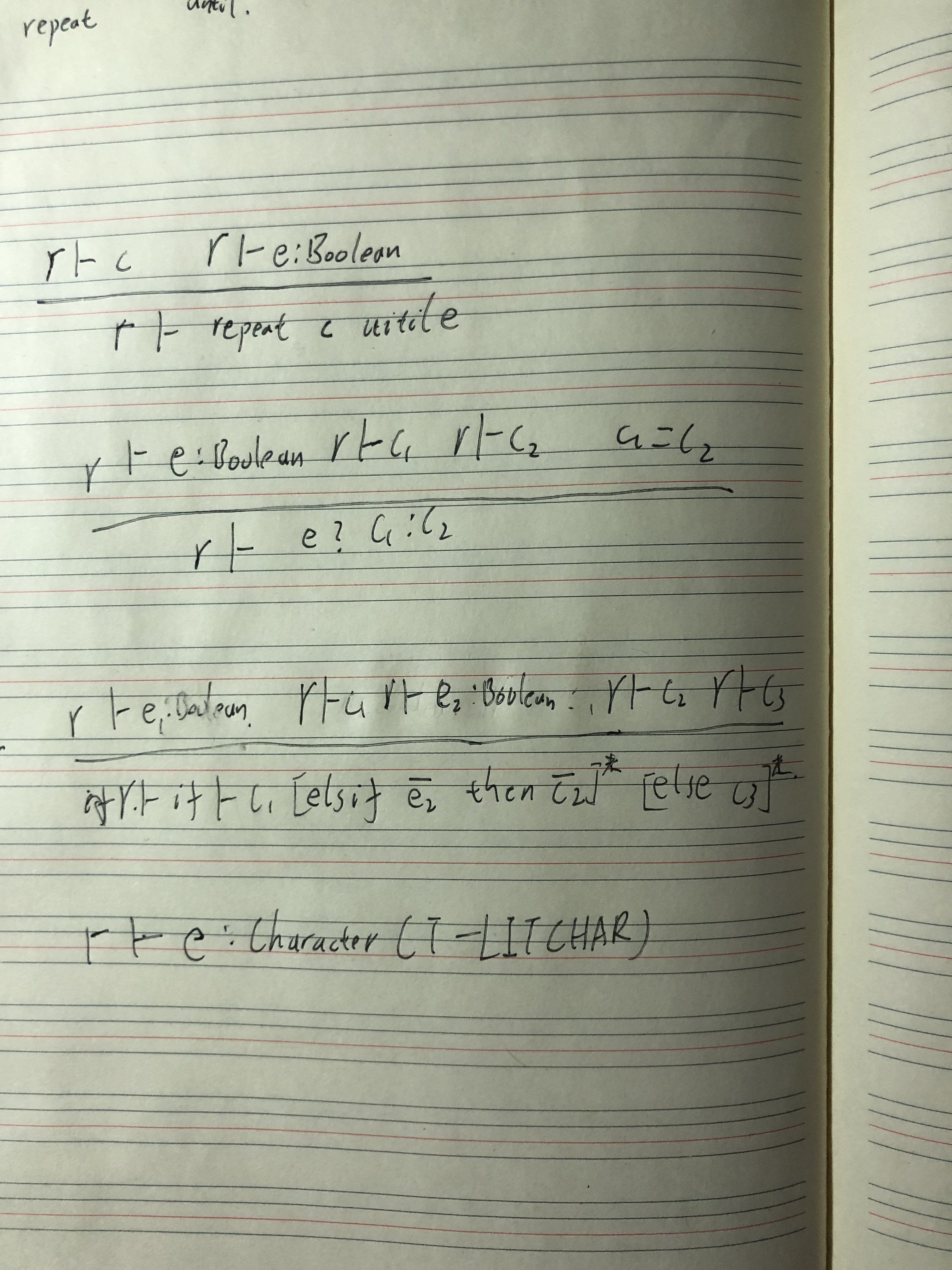

T-IF

T-COND

T-REPEAT

Task II-2:

Character:

Add Character type in Type.hs

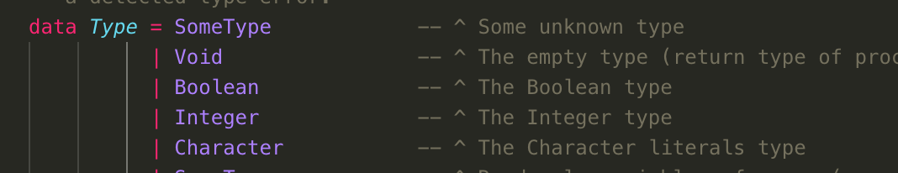

Modify MTStdEnv.hs

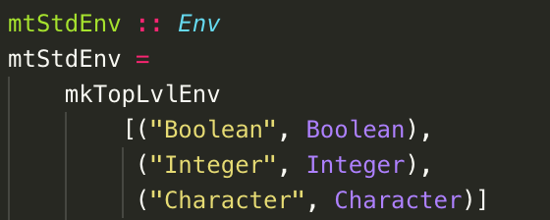

Modify TypeChecker.hs

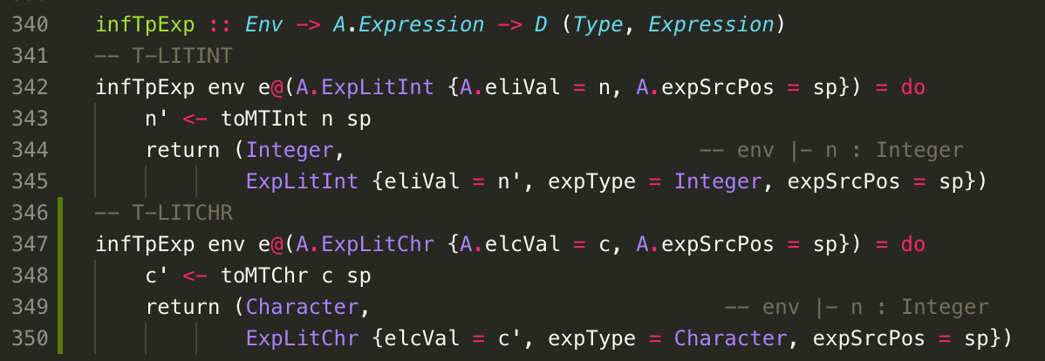

Repeat until loop:

Modify MTIR.hs

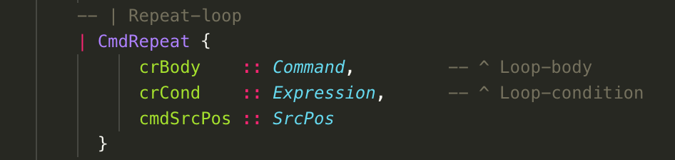

Modify PPMTIR.hs

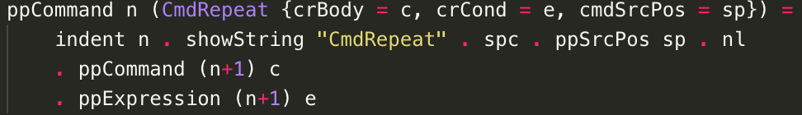

These parts is pretty similar to the AST.hs and PPAST.hs

Modify TypeChecker.hs add chkCmd

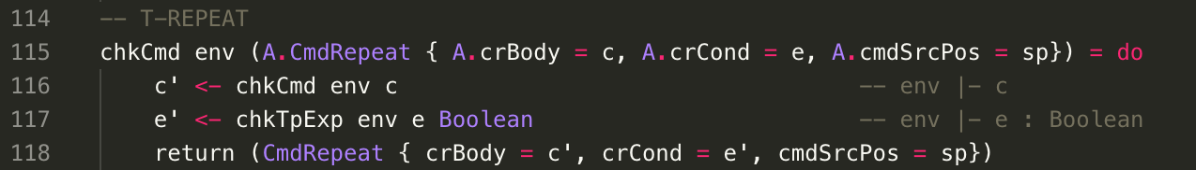

Cond Expression:

Modify MTIR.hs:

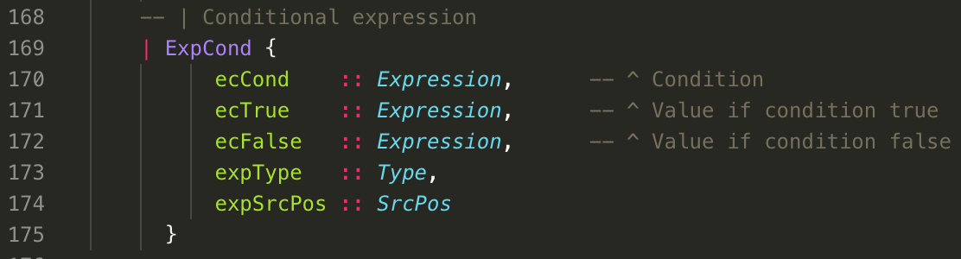

Kind of different from AST.hs Expression should have a type.

Modify PPMTIR.hs:

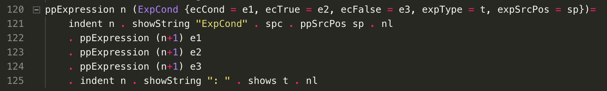

Modify TypeChecker.hs

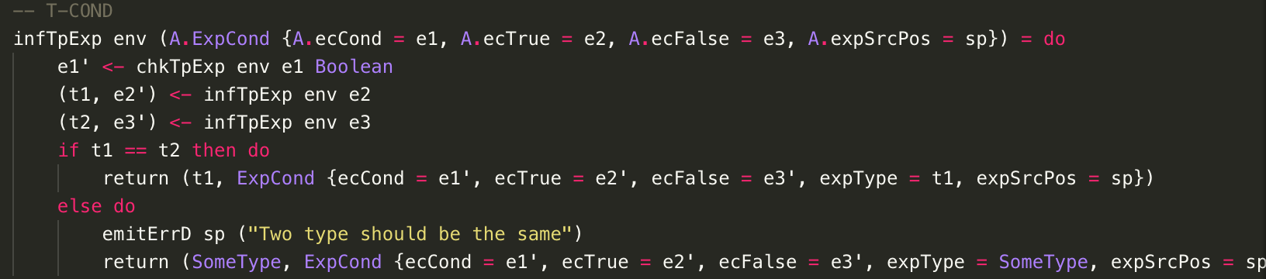

Extended if-then-else-commands:

MTIR.hs

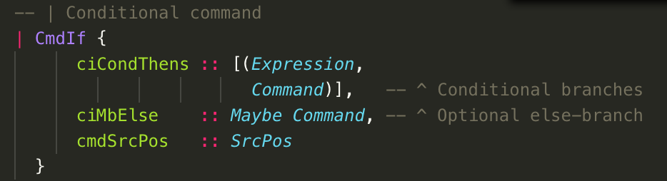

PPMTIR.hs:

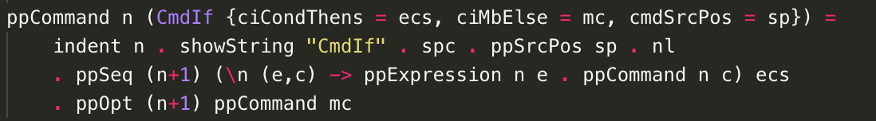

TypeChecker.hs: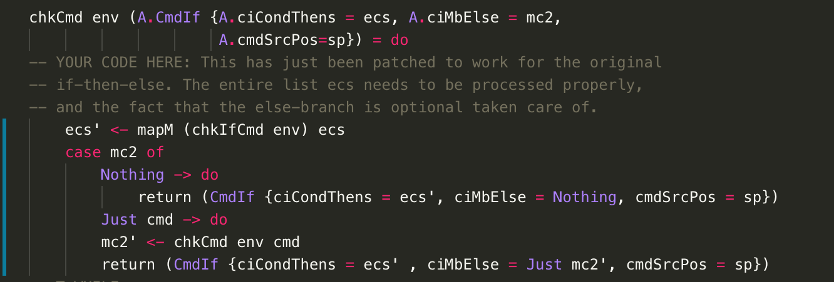

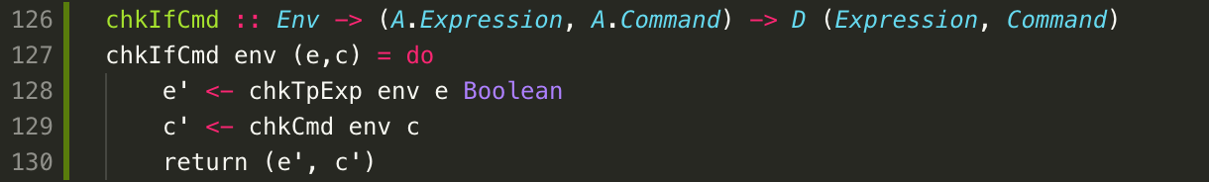

Create a function to check each pair of expression and command

Task II-3:

1. MyTAMCode-3a.tam

LOADL 1

GETINT

#loop:

LOADL 0

LOAD [SB + 1]

LSS

JUMPIFZ #halt

LOAD [SB + 0]

PUTINT

LOAD [SB + 0]

LOADL 1

ADD

STORE [SB + 0]

LOAD [SB + 1]

LOADL 1

SUB

STORE [SB + 1]

JUMP #loop

#halt:

HALT

Result:

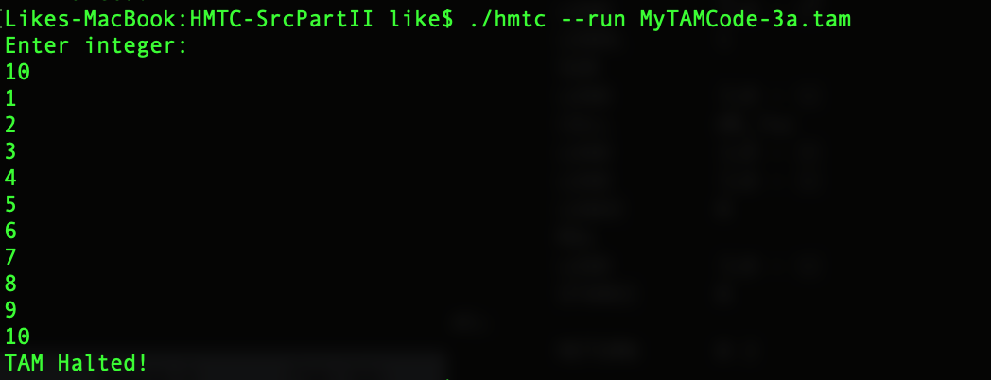

1. MyTAMCode-3b.tam

GETINT

CALL #fac

MUL

PUTINT

HALT

#fac:

LOAD [LB - 1]

LOADL 1

SUB

LOAD [LB + 3]

JUMPIFZ #basecase

CALL #fac

MUL

RETURN 1 0

#basecase:

POP 0 1

LOADL 1

RETURN 1 0

Result:

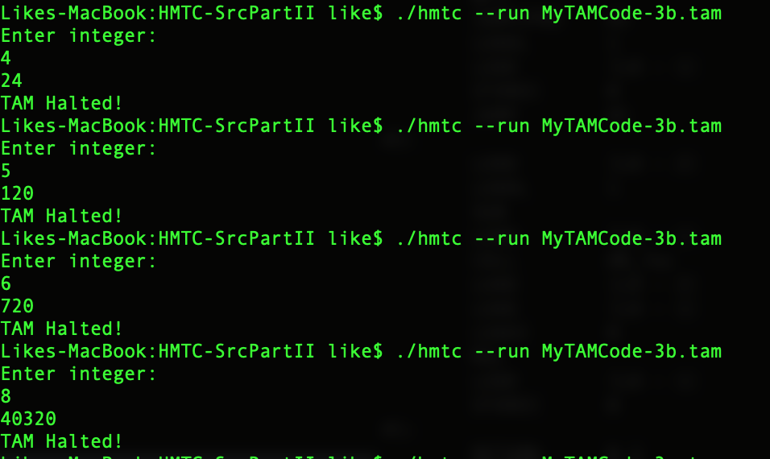

1. LibMT.hs:

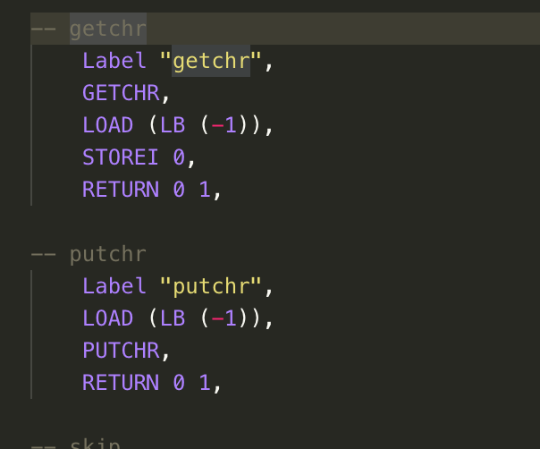

MTStdEnv.hs:



Task II-4: modify codeGenerator .hs

Character type:

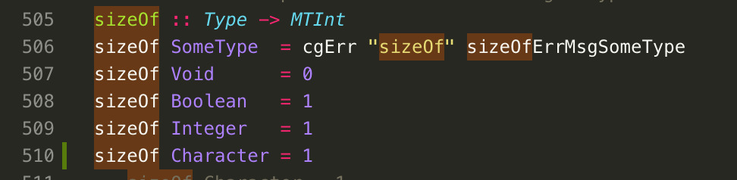

Repeat until loop:

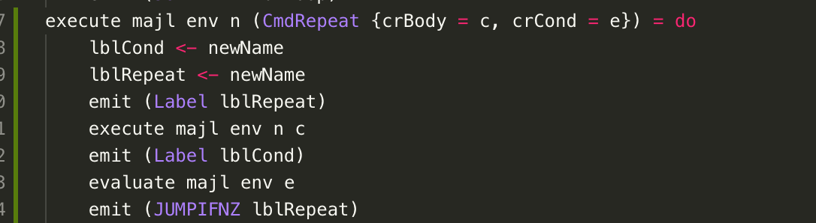

Condition expression:

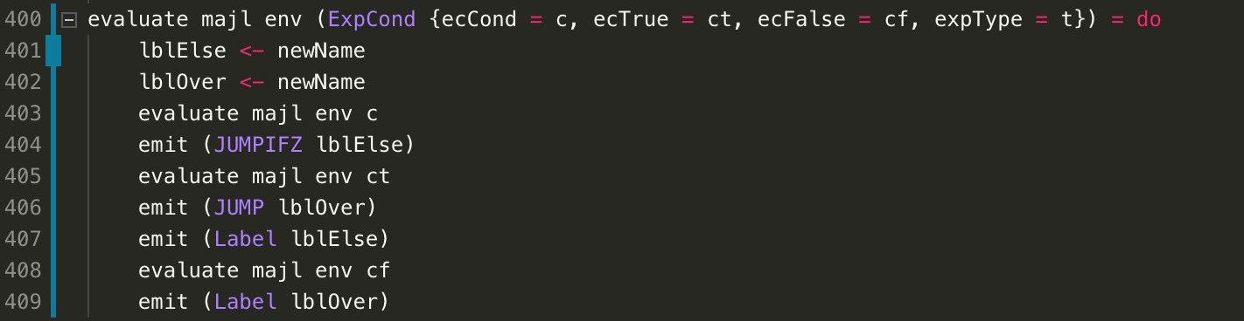

Extend if:

Two part:

